Faculty Profile
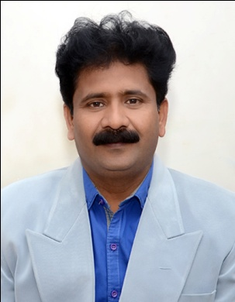

Dr. Chandravadan Mohanrao Naik
Assistant Professor- History
Phone 9036514051
Email: chandravadann99@gmail. Com
Educational Qualification
- Ph.D, Modern Period, Shivaji University, Kolhapur(1999)
- M.A History , Shivaji University ,Kolhapur (1996)

Research / Academic Contribution
- Research Area
Modern Period
- Projects
Minor Research Projects - 02 (Completed.)

1) Historical study of socio-religious Monuments around Nipani Town in Belgaum District of Karnataka State (Rs.55000/ from UGC)

2) A Growth of Textile Industry and study of socio-economic conditions of Textile workers in Ichalkaranji (Rs.95000/ from UGC)

- Research Articles/Papers
Papers Published Total - 33)
S: 05
N: 06
IN: 22
- Books : “Glimpses of Ichalkaranji city” at LULU Publication,USA
- Awards
1.Received “The Hutatma Caption Vasant Kumar Chavan Scholarship” in 1995.
2. Received “Parampujya Harikaka Gosavi Prize” in 1996.
3. First in Entire History Subject in M.A. Examination in Shivaji University (1996)
4. Received Shivaji University, Department Fellowship in 1996 for Ph.D.
5. The International Education and Leadership Summit Awards “Distinguished Faculty Awards” 2015 from Confederation of Indian Universities, New Delhi and Indo Global Chamber of Commerce, Industries and Agriculture Pune, on 15th March 2015
6. Best Teacher Award from Only friendship group , Mangur on 26th January 2016.

