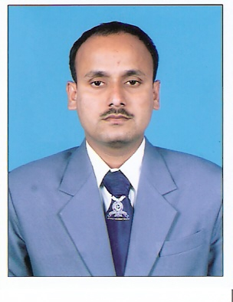
Dr. Santoshkumar Babanrao Yadav
…………………………………………………………………… Assistant Professor – Economics
…………………………………………………………………… Phone: 9921160208
……………………………………………………………………
Email: atharvsby@gmail.com
……………………………………………………………………

Educational Qualifications

- Ph.D., Public Finance, Shivaji University (2008)
- M.Phil., Public Finance, Shivaji University (2005)
- M.A., Economics, Shivaji University (2002)
………………………………………………………………………………………………………
Research / Academic Contribution
- Research Areas
Public Finance, Public Economics
- Research Articles/Papers
Published articles / papers in The Indian Economic Journal (01), Ethos (01), Yojana (01), Samaj Prabodhan Patrika (01) and Arthsanvad (05).
- Other Distinctive Activities
- Executive President, Shivaji University Economic Association, Kolhapur
- Research Guide for Ph. D. / M. Phil, Shivaji University, Kolhapur
- Programme Officer, National Service Scheme (NSS), Devchand College
- Books (Authored / Co-authored)
- Service Tax in India, Publisher – Self - (2009)
- Research Methodology in Economcsi, Nirali Prakashan, Pune (2009)
- Introduction to Research in Economics, Continental Prakashan, Pune (2009)
- Tax and Tax Consultancy (B. A. III Sem V & VI), Phadke Prakashan, Kolhapur (2012)
- Business Economics (B. Com. I Sem. I & II), Phadake Prakashan, Kolhapur (2014)
- Business Economics (B. Com. II Sem. III & IV), Phadake Prakashan, Kolhapur (2015)
- Business Economics – I (M. Com. I Sem I), YCMOU, Nashik (2015)
- Business Economics – I (M. Com. I Sem II), YCMOU, Nashik (2015)
- Research Methodology and Project Work- I (M. Com. II Sem III), YCMOU, Nashik (2016)
- Research Methodology and Project Work- II (M. Com. II Sem IV), YCMOU, Nashik (2016)
- Business Economics (B. Com. III Sem. V & VI), Phadake Prakashan, Kolhapur (2016)
- Micro Economics (B. Com. I Sem. I ), Phadake Prakashan, Kolhapur (2018)
---------------------------------------------------------------------------------------------------------------------

