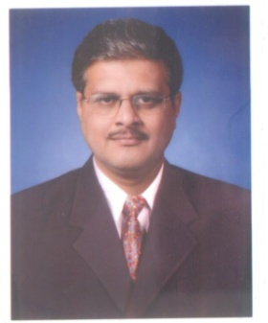
Prof. Dr. Prashant P. Shah
Professor – Electronics
Phone number 07795426115
Email: ppshahanpn@gmail.com
Education qualification
M.Sc. Shivaji University Kolhapur (1988).
D.C.P. Shivaji University Kolhapur (1991).
M.Phil. Process control Simulation and perturbation Analysis Shivaji University Kolhapur (1994).
Ph.D . Design of SMPS using Fuzzy Logic Shivaji University Kolhapur (2008).
Academic Contribution
Experience : 28 years U.G. ,1 year P.G.,13 Year research
Courses : (1 Orientation, 3 Refresher course)
Head, Department of Electronics 1/1/2002 onwards
IQAC coordinator 1-7-2009 to 1-8-2017
Administrative Assistant (Vice Principal) From 1-7-2010
Short term training: 12
Organization of NSS Camps: 4
Contribution for University administration: L.I.C., VC Nominee subject expert, Member of Board of Studies, Member of 48(3) a, Electronics of SUK.
Research : Research papers : IN 15, N3, U2, in conf:2, presented 13,
Attended 18,
chapter in a book
Research guidance: 1 Ph.D. awarded, 3 working
Chairperson/resource person: 8
e-notes 43, ppts 32
Awards: 2

