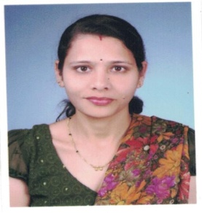

Smt .SushamaArjunJadhav
Head, Department of Sociology
………………………………………………………………………………………………………
Assistant Professor –Sociology
………………………………………………………………………………………………………
Phone: 9766652292
………………………………………………………………………………………………………
Email: jadhavsusharjun@gmail.com
………………………………………………………………………………………………………
Educational Qualification

- M.A., Sociology, Shivaji University (2002)
- SET, Sociology, Pune University (2009)
………………………………………………………………………………………………………
Research / Academic Contribution
- Research Areas
Indian Sociology & Social Movement
- Projects (Completed / Ongoing)
- --------------------
- Research Articles/Papers

Paper Publication |  | Con./Seminar Attendance |  |  | Paper Presented  in Conferences |  |  | Book Editor |  |  | Invited Lectures
ISSN | ISBN | IN | N | R | IN | N | R | IN | N | R
02 |  | 01 | 07 | 12 | 01 | 09 | 05 |  | 01 |  | 02

- Books (Authored / Co-authored/Editor/Co-Editor)
Editor –Social Movements In India (25th Aug.2016)
---------------------------------------------------------------------------------------------------------------------
Awards
- ---------------------

