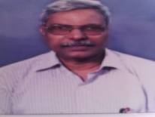

Prof. Nhivekar Suhas Govind
Associate Professor – Political Science
Phone: 7769984272
Email:
Educational Qualification
- M.A., Political Science, Shivaji University (1986)
Research Contribution :
Paper presentation :06 Research Paper presented in National Conferences.
Books:
- Bhartiya Rajkiya Vichar , Vidya Surabhi Prakashan , Kolhapur (2008)
- Maharashtra Shasan anni Rajkaran , Vidya Surabhi Prakashan , Kolhapur (2008)
- Bhartiya Rajyaghatnecha parichay ,Aditya Rushi Prakashan (2016)

