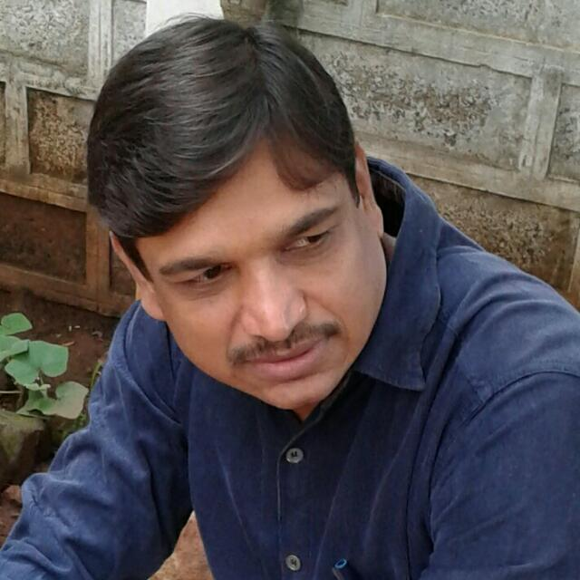
Dr.Ramesh Mahadev Salunkhe
Assistant Professor – Marathi
Phone : 9403572527
Email : avanirs53@yahoo.com
Educational Qualifications
M.A. ,Shivaji University (1995), B.ed, Shivaji University (1994), NET, UGC (1999), SET, PuneUniversity (2000) ,Ph.D., Shivaji University (2015)
Research / Academic Contribution
Research Areas Drama and Novel
Projects (Completed / Ongoing)
Minor Project (UGC) : Vijaya Tendulkar yanchya Natakanmadhil Hinseche Swarup (Ongoing)
Research Articles / Papers
*Anandichya Kaifiyaticha Dhandola this article published in a literary journal Nav-Anushtumb which is based on a novel Gavthan – Krushnath khot 2007
* Tipu sultanche swapna this article published in a magazine Nav-Anushtumb which is based on a drama Tipu sultanche swapna written by Girish karnad 2009
*In quarterly Samaj Prabodhan Patrika G.P.Deshpande as a dramatist this article publised 2013
*Marathi Kadambari ani Samajikta this essay published in Shivim sanshodhan patrika 2015
*A documentary film Pithakshar is produced based on life of an author Mahadev More 2016
*Shruyate na tu drishate, Nepathya raga, Megh prashna, Pukar, Mukhavate these Hindi Dramas are translated in Marathi
Books (Authored /Co - authored)
*Published a Novel SAGARVEDI (Serialize) in Daily Kesari 1994
*Swapnamoliche bandhakam this article is included in a book Nimithe Swapanachya padzadinantar which is written by chandrakant potdar 2018

