Devchand College, Arjunnagar
IQAC
- Name of the Activity: “One Day National Training Program for Teachers”
- Day and Date: Tuesday, 18/02/2020
- Duration: One Day
- Organizing Agency: IQAC and Zoology Department in Association with Climate Reality Project, India (International NGO)
- No. of Participants/Beneficiaries: 93 participants from different Schools & Colleges
- Name of the Resource Persons:

Chief Guest & Resource Person:  Mr. Aditya. Pundir, Country Manager, The Climate Reality Project, India.  Theme: The New Reality, An Overview. A session on Science, Impact and Solutions, followed by question and answer session | Resource Person  Dr Nandini.Deshmukh,  District Manager (Maharashtra), The Climate Reality Project, India.  Theme: Sustainable Development Goals: Relevance in modern education system and vision 2030
Resource Person:
Sheetal Antil, Senior Project Officer, The Climate Reality Project, India
Theme: Green Campus Program and Resources Available to teach SDG and Climate Change in classrooms. Group Activity to identify innovative ideas/steps that can foster education for sustainable development in schools

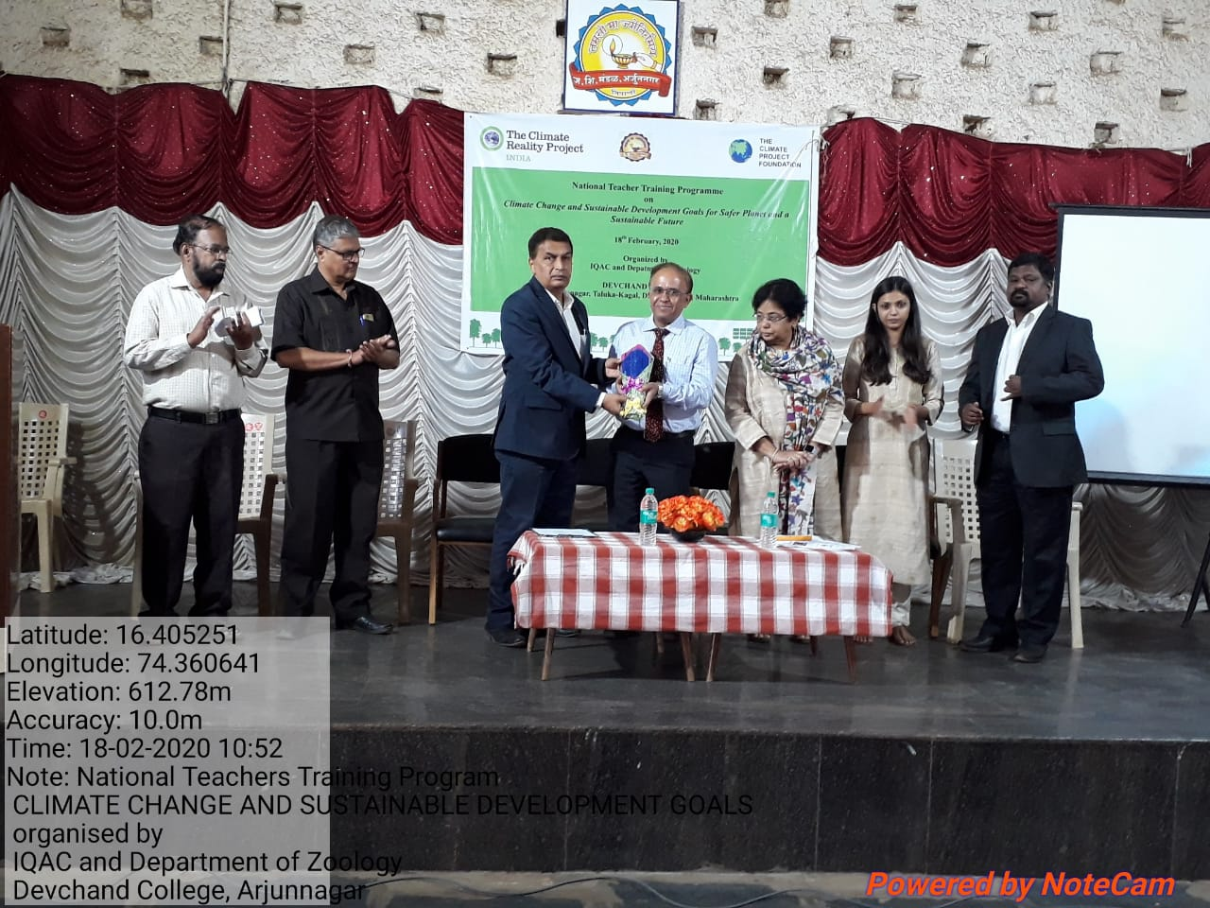 | 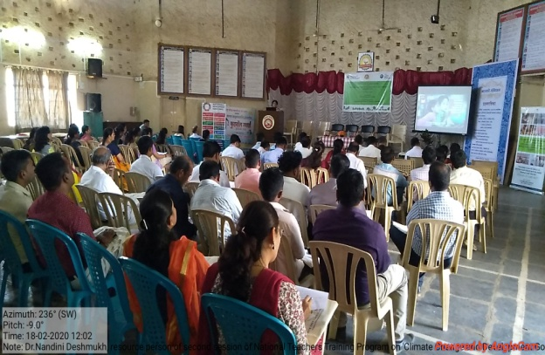
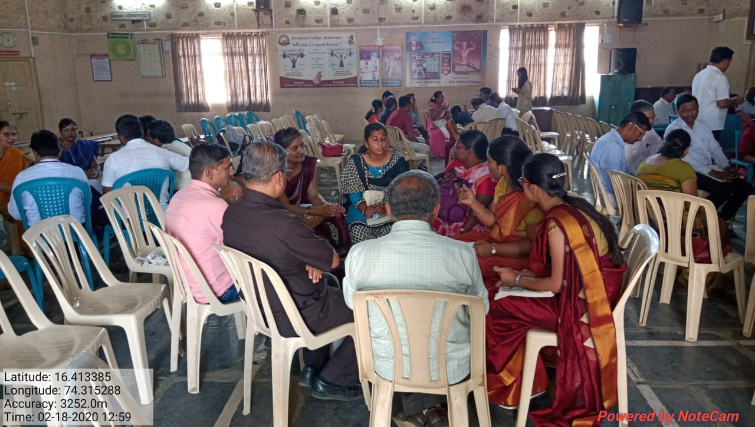 | 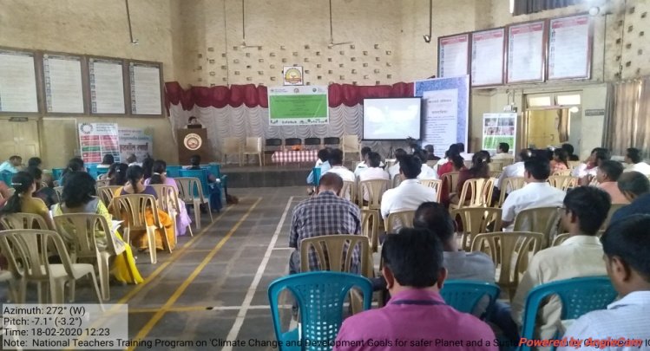
- Photos of the event:

- Feedback Analysis:
Sr. No. | Classification | Excellent | Good | Satisfactory
1 | Theme | 33 (89%) | 04 (11%) | ----
2 | Academic Session- I | 32 (86%) | 05 (14%) | ----
3 | Academic Session -II | 32 (86%) | 05 (14%) | ----
4 | Academic Session –III | 28 (75%) | 08 (22%) | 01 (3%)
5 | Discussion | 28 (75%) | 09 (25%) | ----
6 | Arrangement | 23 (62%) | 09(24%) | 02(6%)
7 | Overall Impact | 27(73%) | 09(24%) | 01(3%)

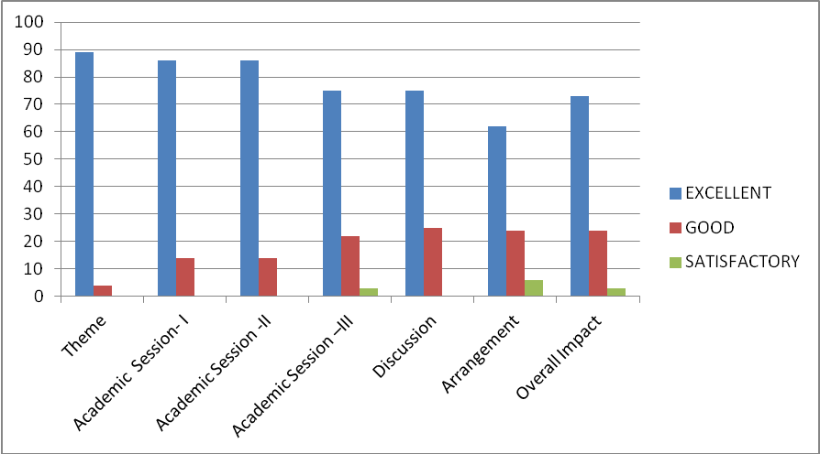
Suggestions:
1. To arrange such training programs for students & society
2. Direction boards/arrows to be placed on campus to reach the venue.

- Outcomes of the activity:
1. The participants became aware of the severity of crisis caused by climate change in 21st century and they understood what can be done on individual level to preserve ecological balance.
2. The participants learnt sustainable development measures and took pledge to follow the same in real life.
3. The participants acquired the skill of developing green campus.


Convener Principal

