Devchand College, Arjunnagar
IQAC
- Name of the Activity: “New Revised NAAC Guidelines”
- Day and Date: Monday, 03/02/2020
- Duration: One Day Workshop
- Organizing Agency: IQAC and Lead College Scheme
- No. of Participants/Beneficiaries: 42 participants
- Name of the Resource Persons:

Chief Guest & Resource Person:  Principal Dr. A.C. Attar  KBP Engineering College,  Satara  Topic: New NAAC Guidelines | Resource Person  Dr. Sarita Patil  Head, Department of Physics & IQAC Coordinator, Sanjay Ghodawat University, Atigre, Dist: Kolhapur  Topic: Documentation for SSR

- Feedback Analysis:
Sr. No. | Event | Excellent | Good | Satisfactory
1 | Theme of Workshop | 24 | 05 | 00
2 | Academic Session I | 23 | 05 | 01
3 | Academic Session II | 21 | 08 | 00
4 | Discussion Session | 18 | 10 | 01
5 | Arrangement of the Program | 16 | 12 | 01
6 | Oral Impact | 21 | 07 | 01

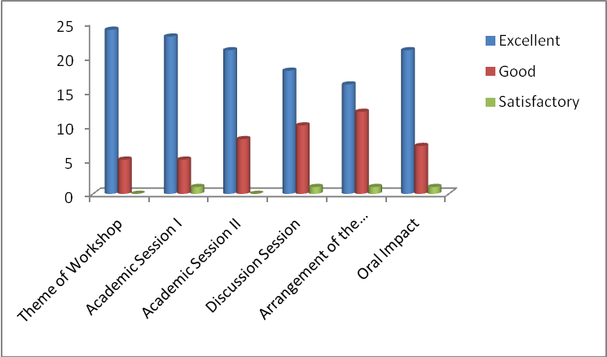
Suggestions:
1. For the resource person more time should be given.
2. The conference pad should be providing.

- Photos of the event:
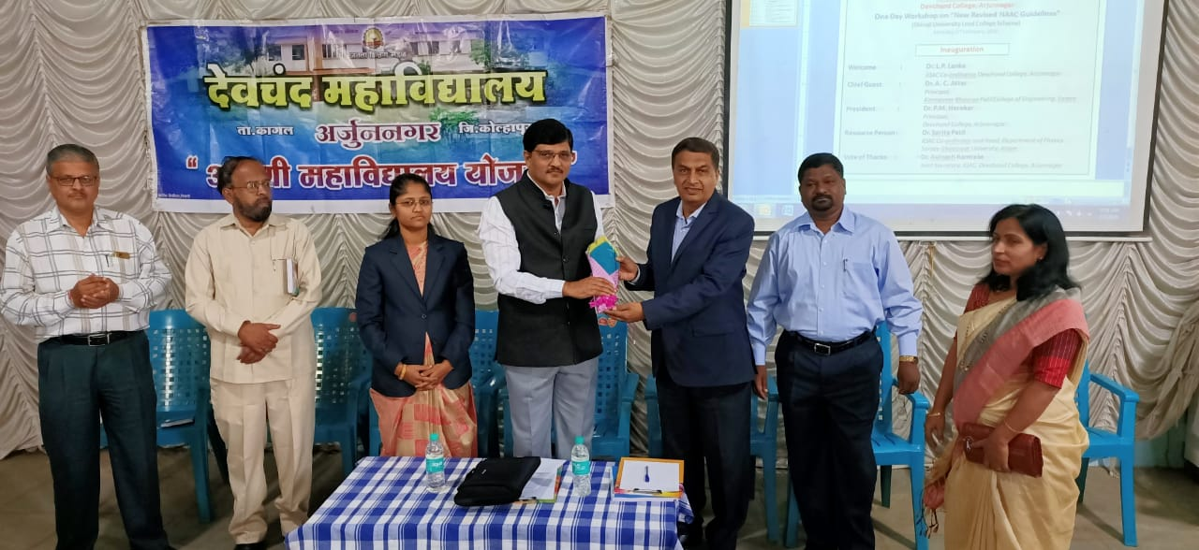 | 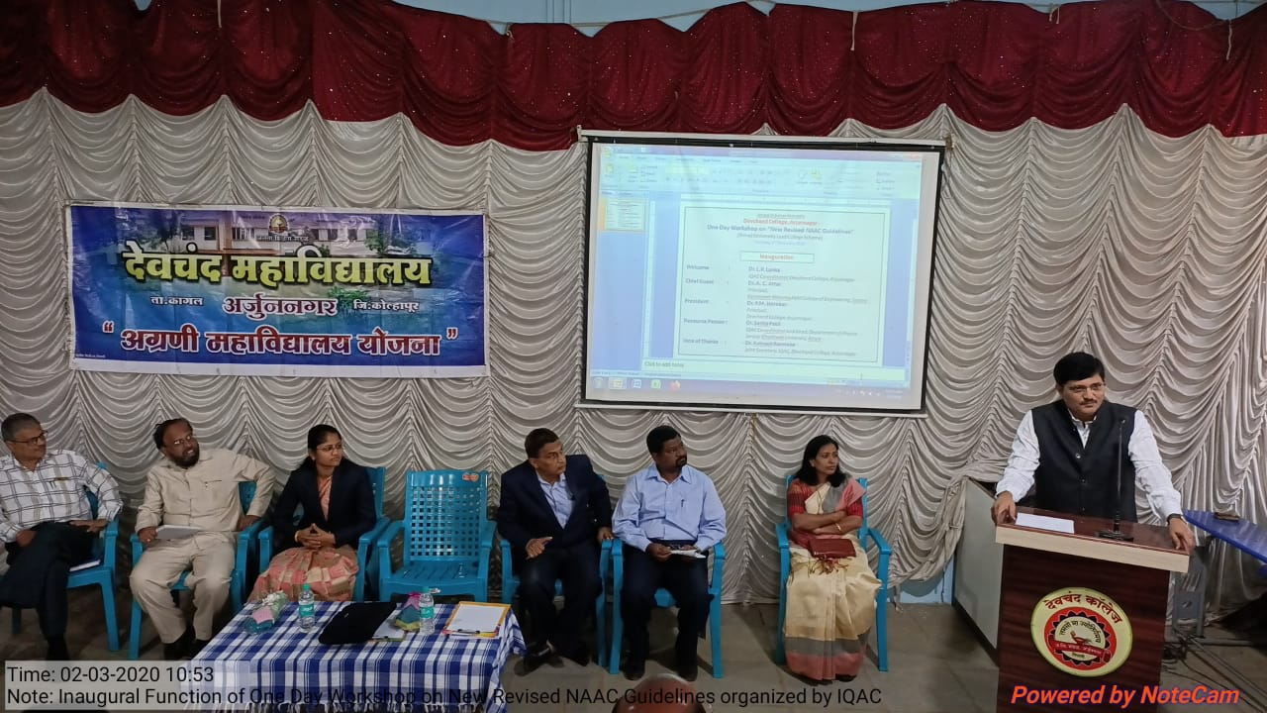
 | 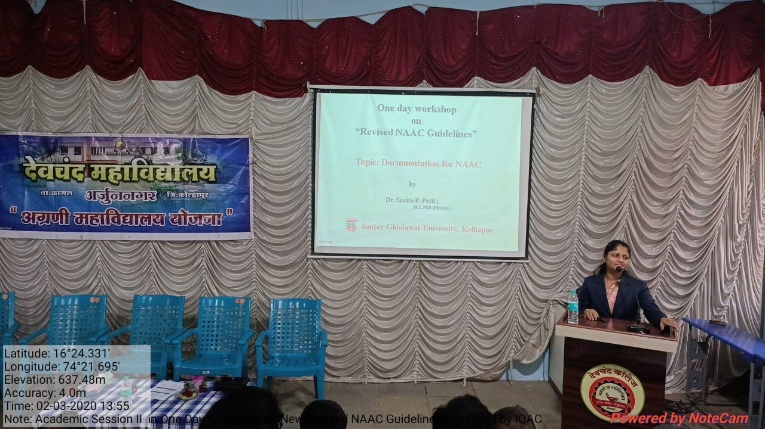

- Outcome of the activity:
1. All the faculty understood the newly revised NAAC guidelines.
2. The faculty acquired the skill of documentation required for NAAC.
3. The faculty realized the need of proper planning and implementation of the plans in a time-
bound manner. 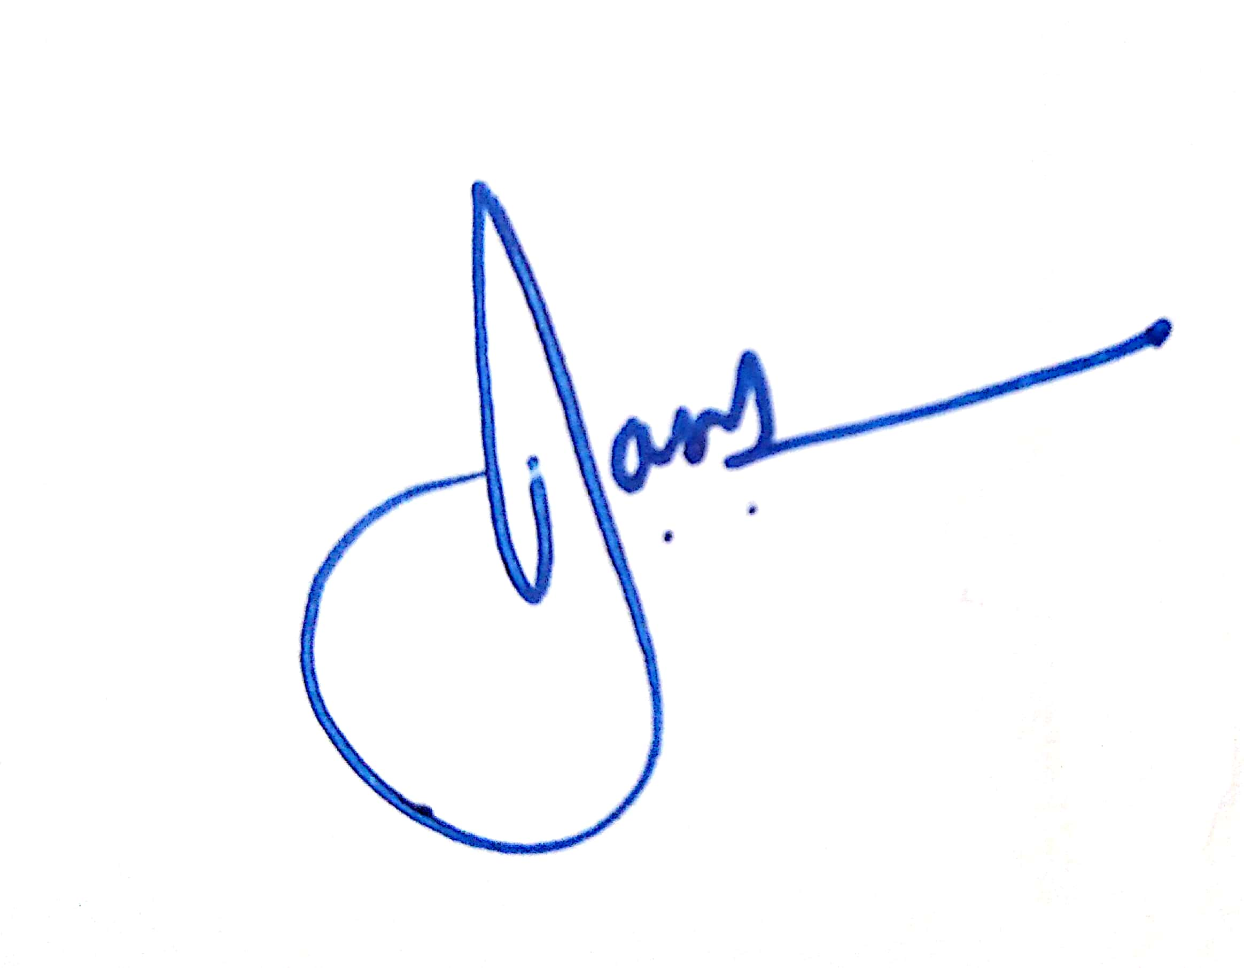 
Convener Principal

