Marathi Rajabhasha Gaurav Din
27 February 2021
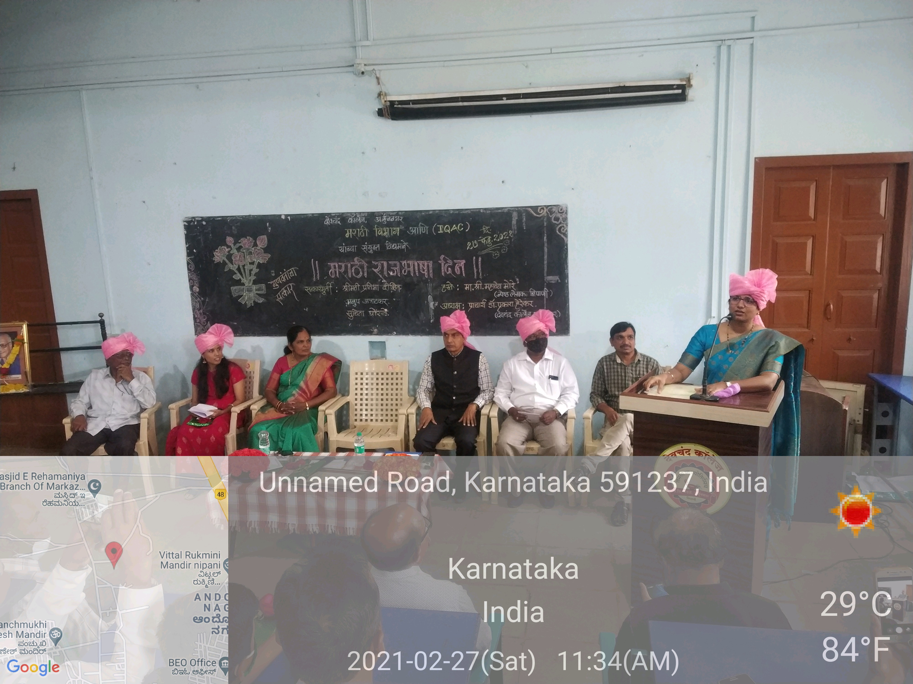
The program on the occasion of Marathi Rajabhasha Din was jointly organised by Department of Marathi and Internal Quality Assurance cell Devchand College Arjunnagar .The veteran writer of the border area Mr.Mahadev More was felicitated for his collection of short stories Davana, Zumbad and Cheharymagache Chehare.These books won the state government awards. The budding writer and Marathi short film Director Mr. Anup Jatratkar's newly published one act play Nishparna Pimpalachya Chhayet won Vijay Tendulkar award.The ex-student of our college Mrs.Sucheta Ghorpade published her first collection of stories Khurapa .The two newcomers have been felicitated by our college for their service of Marathi literature. Mrs.Pratibha Dikshit ,the administrative officer divisional Joint director office (higher education )Kolhapur was felicitated for her remarkable support and to get benefit of Chhatrapati Rajarshi Shahu Scholarship service to our students. Prof.Nanasaheb jamdar was felicitated for his remarkable contribution in creating website Sahitya Vedi .Mr Deepak Kothari, senior clerk ,was felicitated for his dedication towards obtaining Rajarshi Shahu Maharaj scholarship. While replying,the dignitaries shared their views on the occasion of Marathi Rajya Bhasha Gourav Din. Mrs Pratibha Dikshit shared that it is a sacred work to provide scholarship to the students and she is proud and satisfied that she has contributed to the Welfare of the students by pursuing it continuously. A new tab was created for the above purpose. Mr Anup t Jatratkar was unable to attend the function due to his pre-arranged work so his father Dr.N.D. Jatratkar read out his letter.In it he expressed his gratitude for this initiative and felicitation. Mrs Sucheta Ghorpade expressed her inspiration and intention behind writing. The most senior and veteran writer Mr Mahadev More referred his memories and his close relationship with Kusumagraj and also commented in brief about present Marathi literature and its situation.I n the presidential address honorable principal Dr P.M. Herekar extended his special thanks to Mrs Pratibha Dikshit for working hard to provide scholarship to the students in the border area.He also expressed his thanks and sympathy for the literary services of veteran writer Mr Mahadev More and newcomers Mr Anup Jatratkar and Mrs.Sucheta Ghorpade. Dr Ramesh Salunkhe, the head of Marathi Department, gave introductory speech and Dr L. P. Lanka the convener of I.Q.A.C. thanked for the event and the entire event was compered by Prof. Mrs Asha Khot.


